PROBLEM STATEMENT:

QUERY:

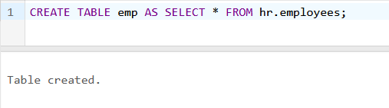

1. List the Enames those are having five characters in their first names.

QUERY:



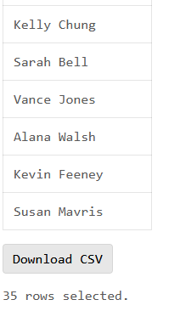

2. List the Enames those are starting with ‘S’ and with five characters in their firstname.

QUERY:

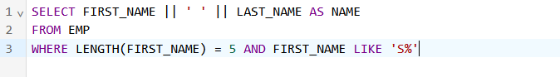

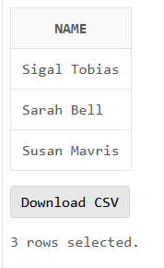

3. List the Five character names starting with ‘S’ and ending with ‘H’.

QUERY:





4. Display the employee last_name concatenated with first_name, the length of the employee last_name .

QUERY:

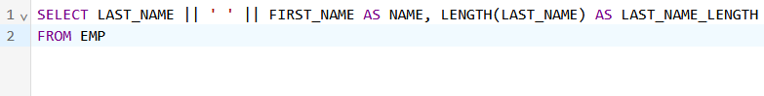

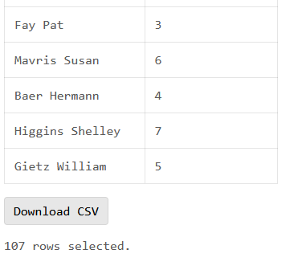

5. Display the numeric position of the letter ‘a’ in employee last name for all the employees who have the string REP contained in the jobid starting at the fourth position of the job id.

QUERY:

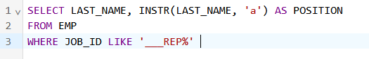 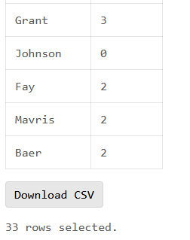

6. Write a query that display the employee’s last names with the first letter capitalized & all other letters lowercase & length of the names for all employees whose name stats with J, A or M. Also sort the results by employees last name.

QUERY:

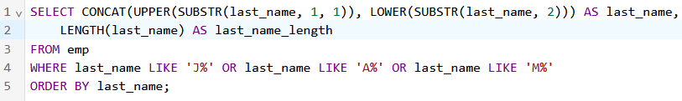

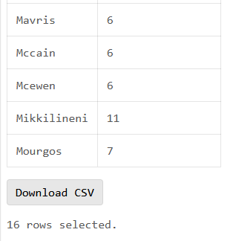

7. Calculate the remainder of a salary after it is divided by 5000 for all employees whose job_id is SA_REP.

QUERY:

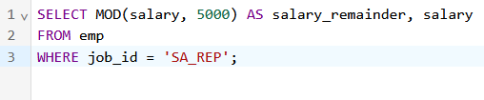 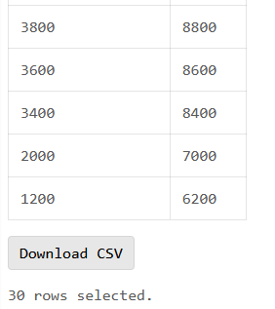

8. For each employee, display the employee number, last_name & salary increased by 15% & expresses as a whole number.

QUERY:

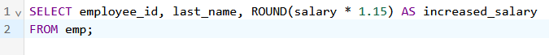

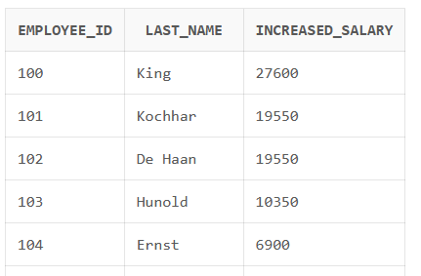

9. Create a query to display the last name & salary for all employees. Format the salary to be 15 characters long, left padded with $. Label the column Salary.

QUERY:

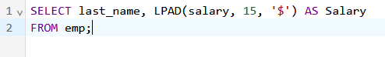

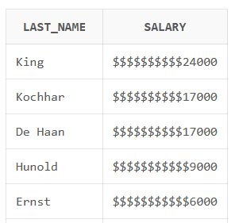

10. Calculate the job experience of all employees. Display it with hiredate and the new column heading Experience in months and experience in years.

QUERY:

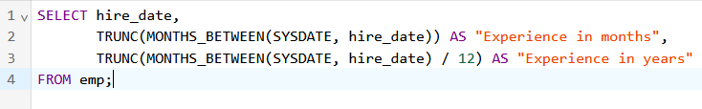

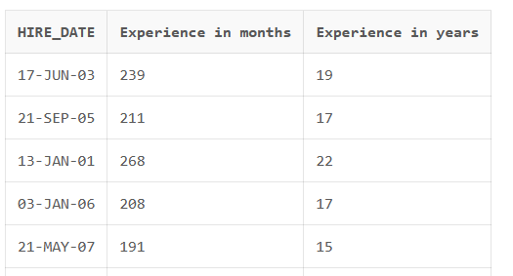

11. Display the employee number, hiredate, number of months employed, six month review date, first Friday after hire date and last day of the hiremonth for all employees.

QEURY:

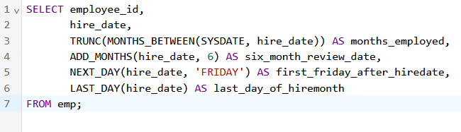

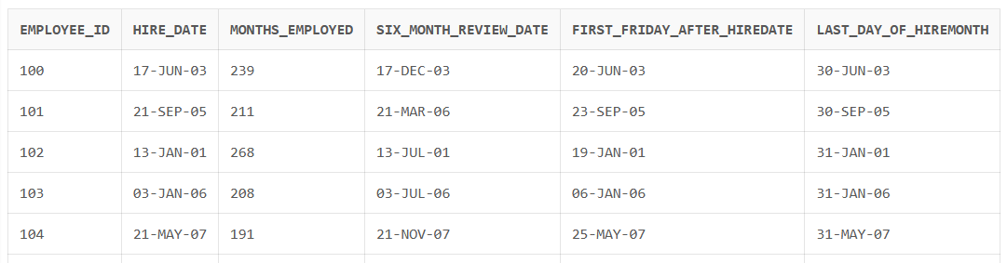

12. Display the employees last name & calculate the number of months between today & Date the employee was hired. Label This column as months_worked.

QUERY:

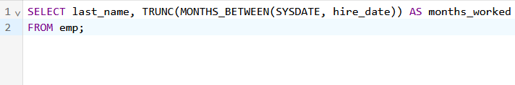

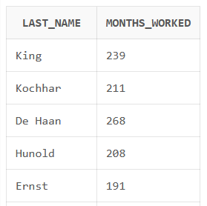

13. Display the names & hiredate along with the time of all the employees who joined on May 24,1999.

QUERY:

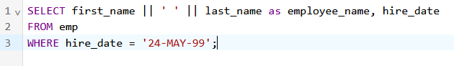



14. To find employees hired before 1990.

QUERY;

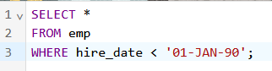



15. Display each employee last name, hire date & day of the week on which the employee started. Order the results y the day of the week .

QUERY:

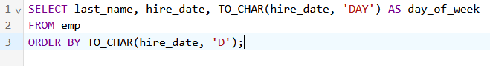

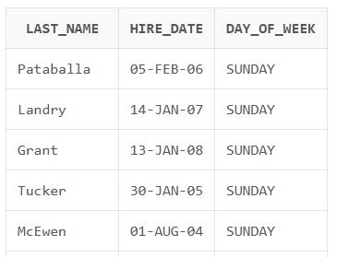

16. Create a query that display the employees last name & comm. Amounts. If an employee does not earn commission put, ”No commission”.

QUERY:

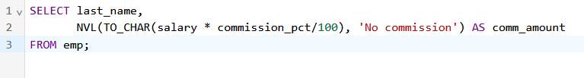

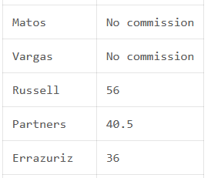

17. Create a query to calculate the annual salary and annual compensation of all the employees.

QUERY:

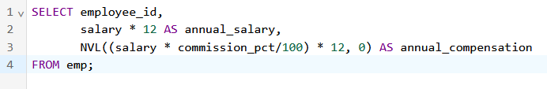

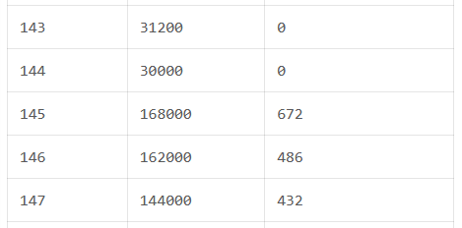

18. Create a query that display the employees last name & manager_id . If an employee does not have manager display , ”No manager”.

QUERY:



